**Q.1 Write separate programs to implement all types of Inheritance.**

**Single Inheritance**

class Student{

int roll=5;

String name="Manthan";

int java=75;

int dsa=80;

void display()

{

System.out.println("\nStudent Information\n");

System.out.println("Roll No : "+roll+"\nName : "+name);

}

}

class Result extends Student{

int total=java+dsa;

void show()

{

System.out.println("Total Marks : "+total);

}

}

class SingleInheritance{

public static void main(String args[]){

Result r=new Result();

r.display();

r.show();

}

}

**Output :**

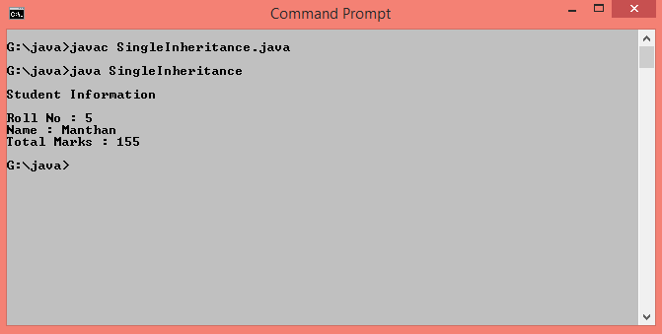

**Multilevel Inheritance**

class Student{

int roll=3;

String name="Siddhi";

int java=76;

int dsa=80;

void display()

{

System.out.println("\nStudent Information\n");

System.out.println("Roll No : "+roll+"\nName : "+name);

}

}

class Marks extends Student{

int total=java+dsa;

void show()

{

System.out.println("Total Marks : "+total);

}

}

class Result extends Marks{

void showResult(){

if(total>=70 && total<=200){

System.out.println("You Are Passed\nPercentage :"+(total/2));

}

else{

System.out.println("You Are Failed");

}

}

}

class MultilevelInheritance{

public static void main(String args[]){

Result r=new Result();

r.display();

r.show();

r.showResult();

}

}

**Output :**

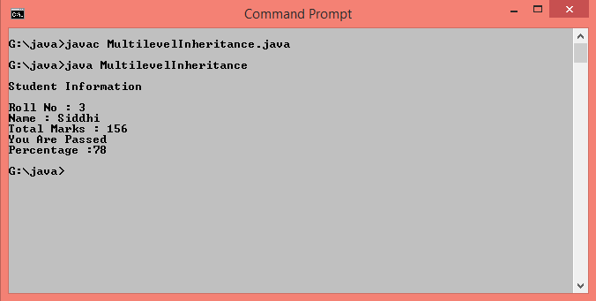

**Hierarchical Inheritance**

class Number{

int num1=153,num2=343;

void displayNumber(){

System.out.println("\n Number 1 : "+num1+"\n Number 2 : "+num2);

}

}

class Armstrong extends Number{

int temp=num1,rem,sum=0;

void showArmstrong(){

while(num1>0){

rem=num1%10;

sum=sum+(rem*rem*rem);

num1=num1/10;

}

if(temp==sum)

System.out.println(+temp+" is Armstrong Number.");

else

System.out.println(+temp+" is not Armstrong Number.");

}

}

class Palindrome extends Number{

int temp=num2,rem,rev=0;

void showPalindrome(){

while(num2>0){

rem=num2%10;

rev=(rev*10)+rem;

num2=num2/10;

}

if(temp==rev)

System.out.println(+temp+" is Palindrome Number.");

else

System.out.println(+temp+" is not Palindrome Number.");

}

}

class HierarchicalInheritance{

public static void main(String[] args){

Armstrong a=new Armstrong();

a.displayNumber();

a.showArmstrong();

Palindrome p=new Palindrome();

p.showPalindrome();

}

}

**Output :**

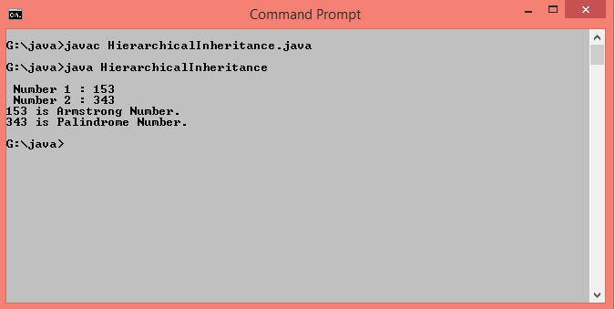

**Hybrid Inheritance**

class Student{

int seatno=1960;

String name="Rutuja Santosh Kadam";

void display(){

System.out.println("\n Seat Number : "+seatno+"\n Name : "+name);

}

}

class JEE extends Student{

int JEEmarks=288;

void displayJEE(){

System.out.println(" JET Marks : "+JEEmarks);

}

}

interface CET{

public void displayCET();

}

class Result extends JEE implements CET{

int CETmarks=180;

public void displayCET(){

System.out.println(" CET Marks : "+CETmarks);

if(JEEmarks>=275 && JEEmarks<=300 && CETmarks>=175 && CETmarks<=200)

System.out.println("You are eligible to take admission in DY patil College.");

else

System.out.println("You are not eligible to take admission in DY patil College.");

}

}

class HybridInheritance{

public static void main(String args[]){

Result r=new Result();

r.display();

r.displayJEE();

r.displayCET();

}

}

**Output :**

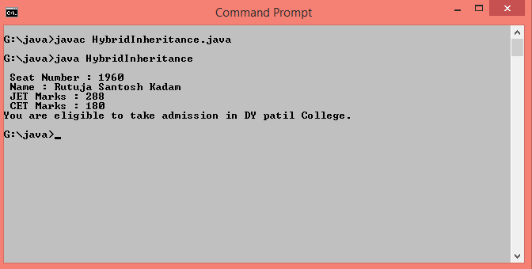

**Multiple Inheritance**

class Person{

int age=50;

String name="Santosh Vithoba Kadam";

void show(){

System.out.println("\n Name : "+name+"\n Age : "+age);

}

}

interface test{

public void display();

}

class Result extends Person implements test{

public void display(){

if(age>=45 && age<=100)

System.out.println(" You are eligible for Covid-19 Vaccine");

else

System.out.println(" You are not eligible for Covid-19 Vaccine");

}

}

class MultipleInheritance{

public static void main(String args[]){

Result r=new Result();

r.show();

r.display();

}

}

**Output :**

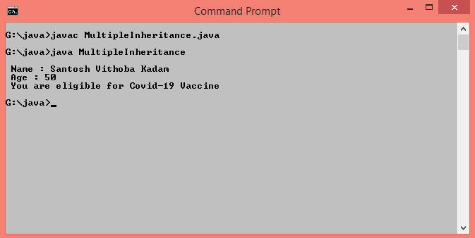

**Q.2 Write a program to implement multilevel inheritance with parameterized constructors defined in each class.**

class Addition{

Addition(int a,int b){

System.out.println("Addition : "+(a+b));

}

}

class Substraction extends Addition{

Substraction(int a,int b){

super(a,b);

System.out.println("Substraction : "+(a-b));

}

}

class Multiplication extends Substraction{

Multiplication(int a,int b){

super(a,b);

System.out.println("Multiplication : "+(a*b));

}

}

class Division extends Multiplication{

Division(int a,int b){

super(a,b);

System.out.println("Division : "+(a/b));

}

}

class Multilevel{

public static void main(String args[]){

Division d=new Division(20,5);

}

}

**Output :**

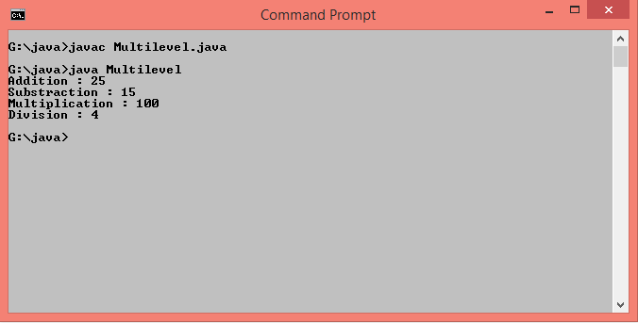

**Q.3 Write a program to define interface “Area” for calculating area of shape. Define classes Square and Triangle to implement the interface “Area”.**

interface Area{

public void calArea();

}

class Square implements Area{

public void calArea(){

int side=5;

System.out.println("\nArea of Square : "+(side*side));

}

}

class Triangle implements Area{

public void calArea(){

int base=5,height=8;

System.out.println("Area of Triangle : "+(0.5*base*height));

}

}

class Interface{

public static void main(String args[]){

Square s=new Square();

Triangle t=new Triangle();

s.calArea();

t.calArea();

}

}

**Output :**

